Lab 09a - Implement Web Apps

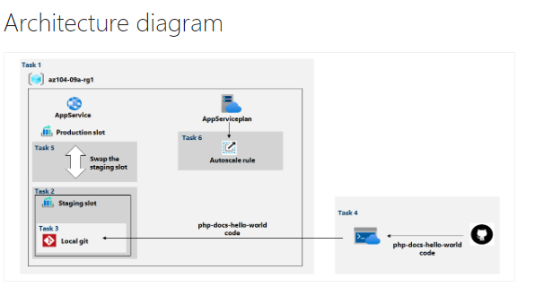

* Task 1: Create an Azure web app.
  + In this task, you will create an Azure web app.

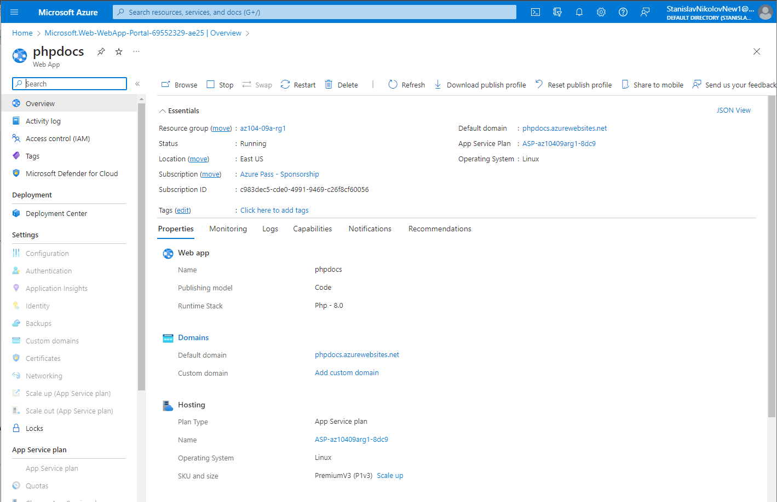

* + Created new app service.
* Task 2: Create a staging deployment slot.
  + In this task, you will create a staging deployment slot.

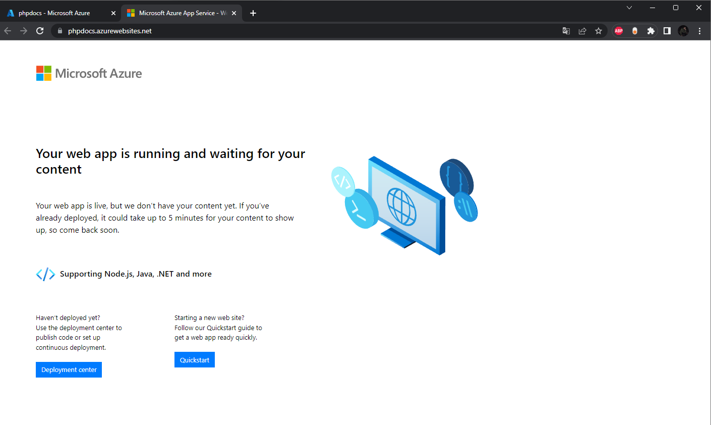

* + Phpdocs slot opening in the browser.

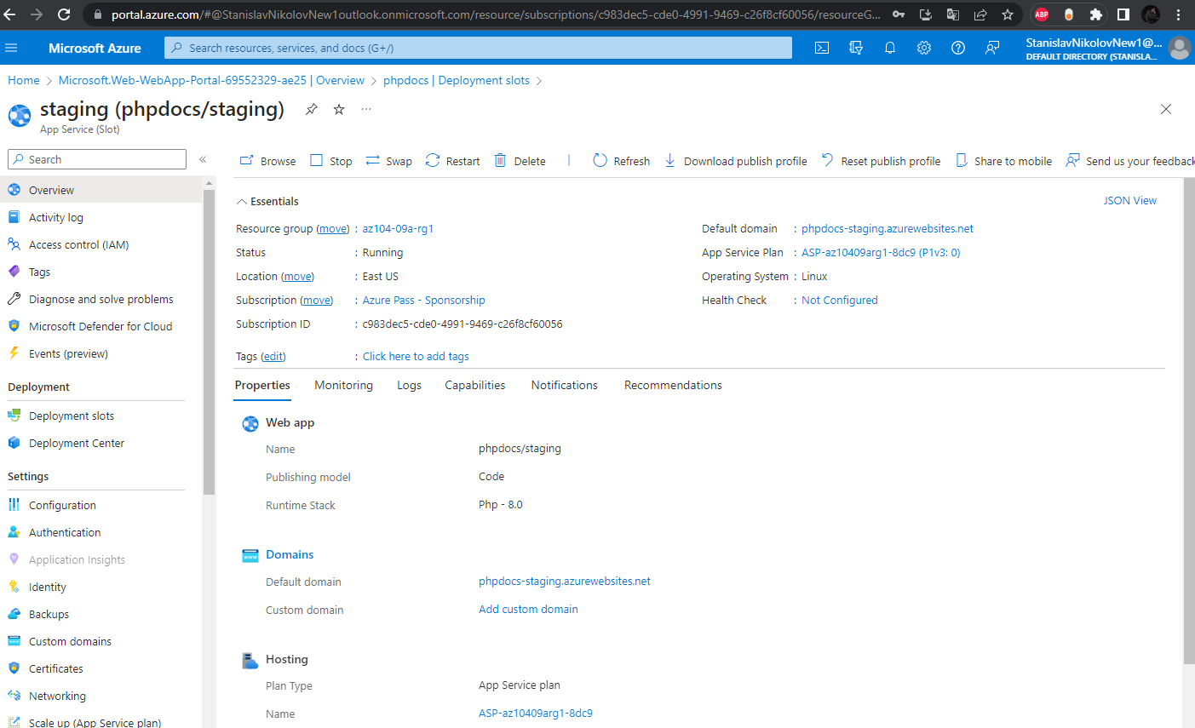

* + Creating a new slot

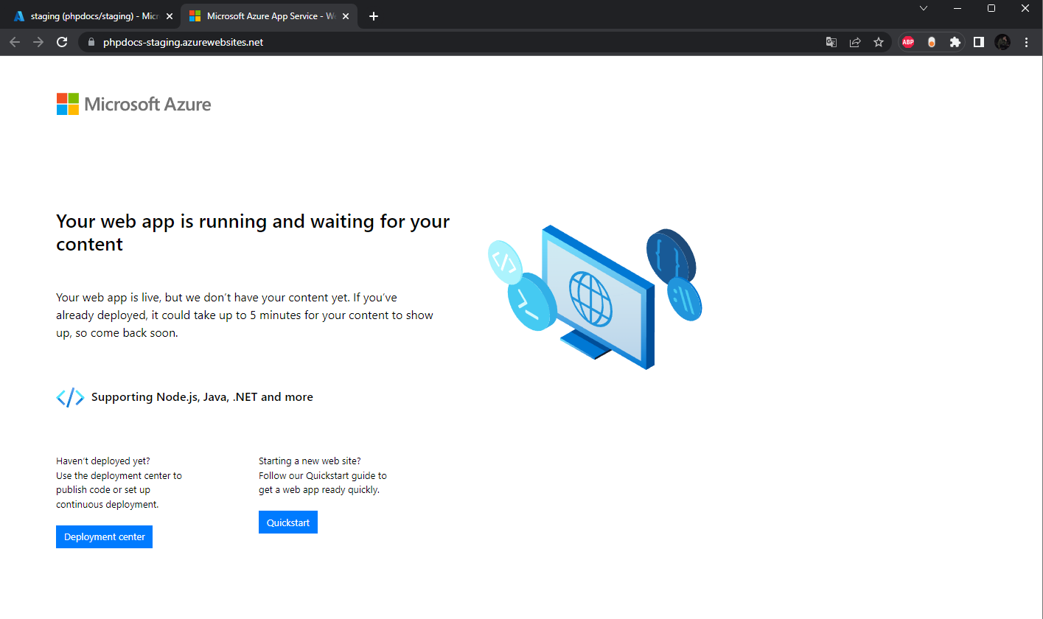

* + Opening the new slot
* Task 3: Configure web app deployment settings.
  + In this task, you will configure web app deployment settings.
  + Git Clone URL:

https://phpdocs-staging.scm.azurewebsites.net:443/phpdocs.git

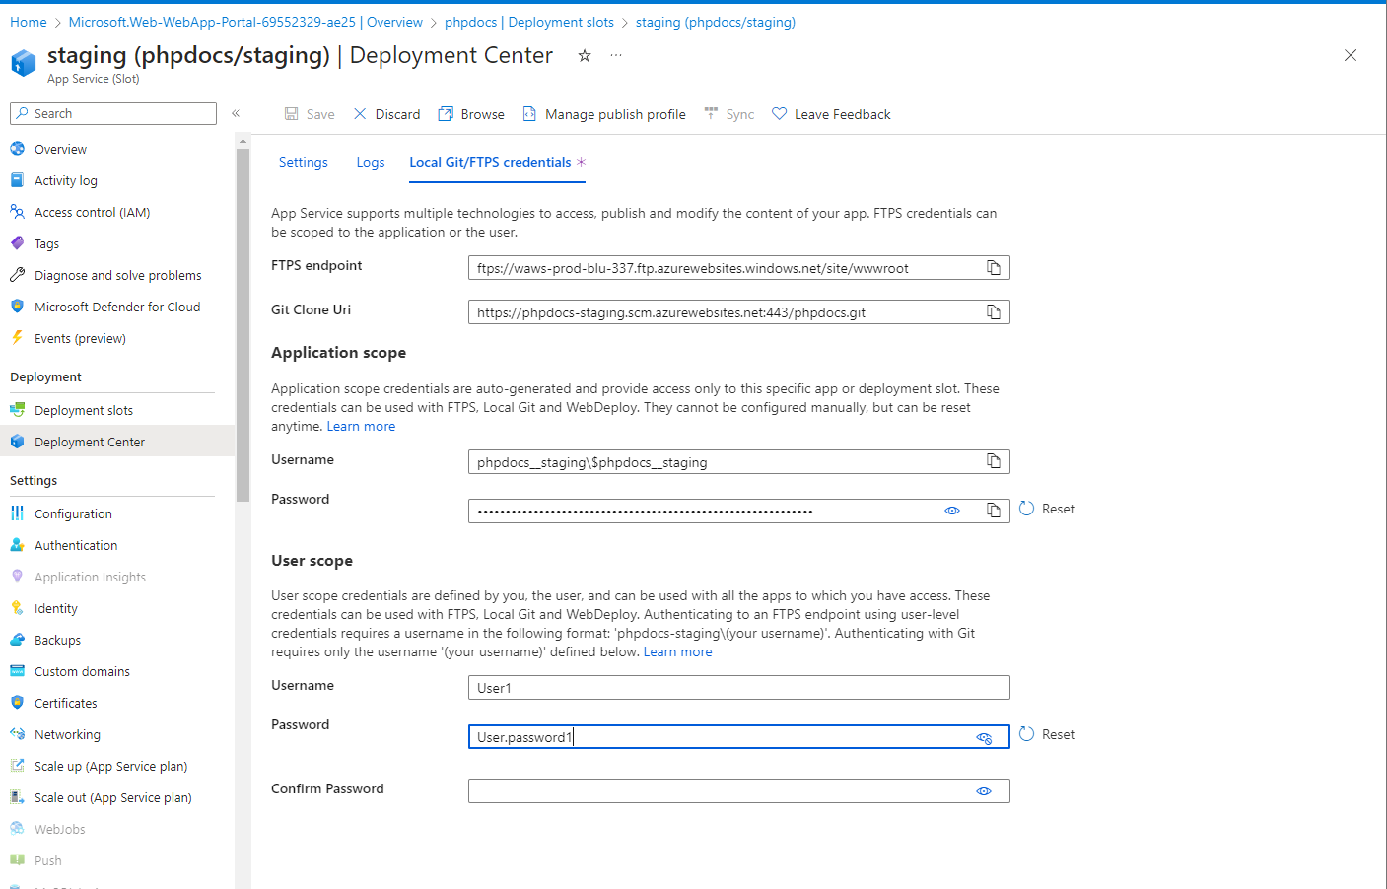

* + Creating a new user and setting the LocalGit.
* Task 4: Deploy code to the staging deployment slot.
  + In this task, you will deploy code to the staging deployment slot.

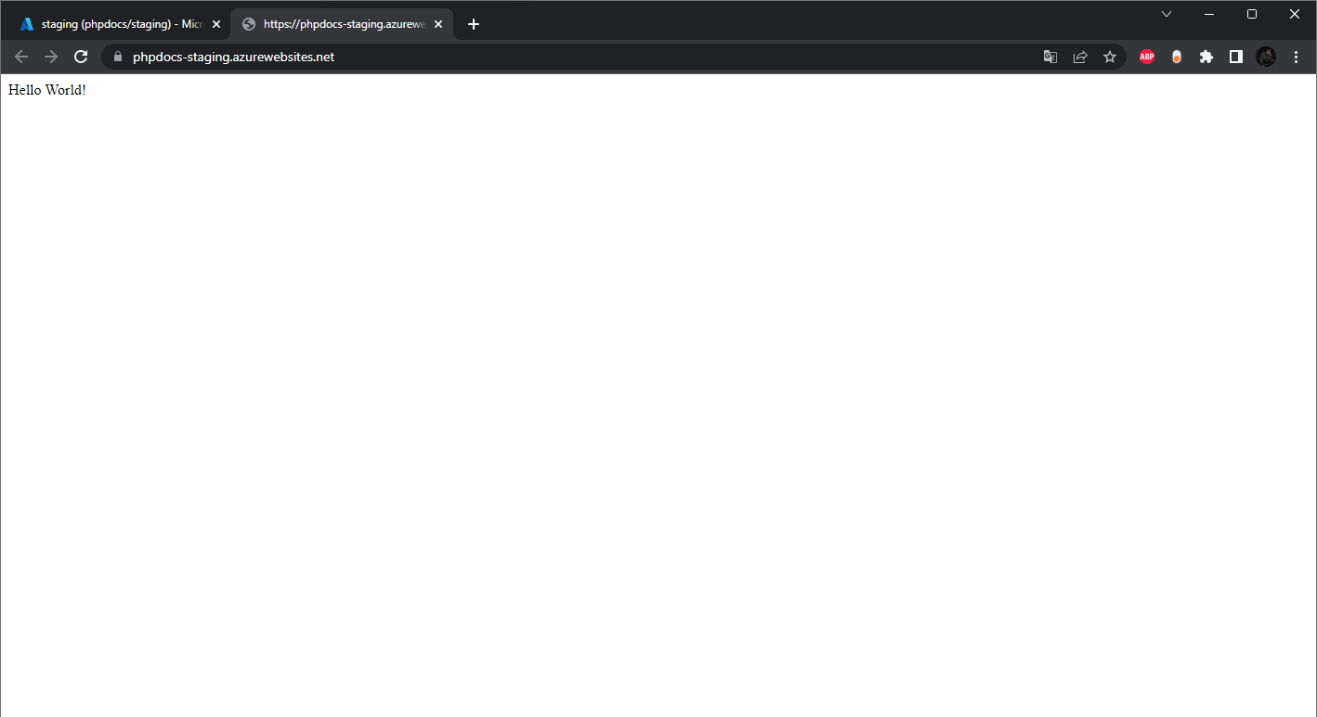

* + Verifying that the output of the client is “hello world”.
* Task 5: Swap the staging slots.
  + In this task, you will swap the staging slot with the production slot

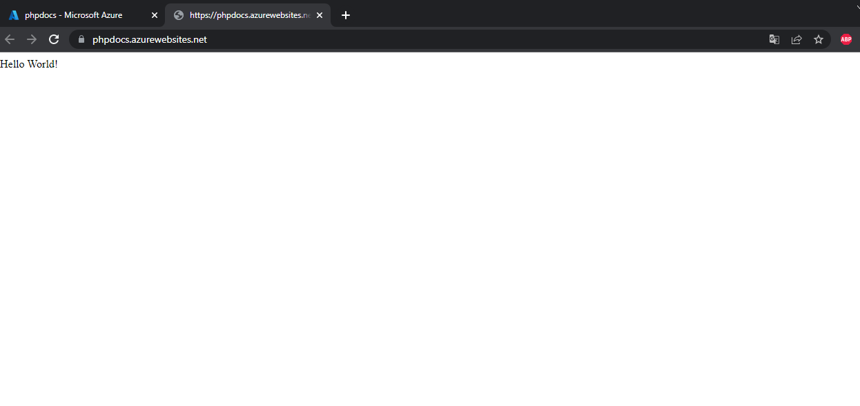

* + Verifying that the web page is replaced.
* Task 6: Configure and test autoscaling of the Azure web app.
  + In this task, you will configure and test autoscaling of Azure web app.

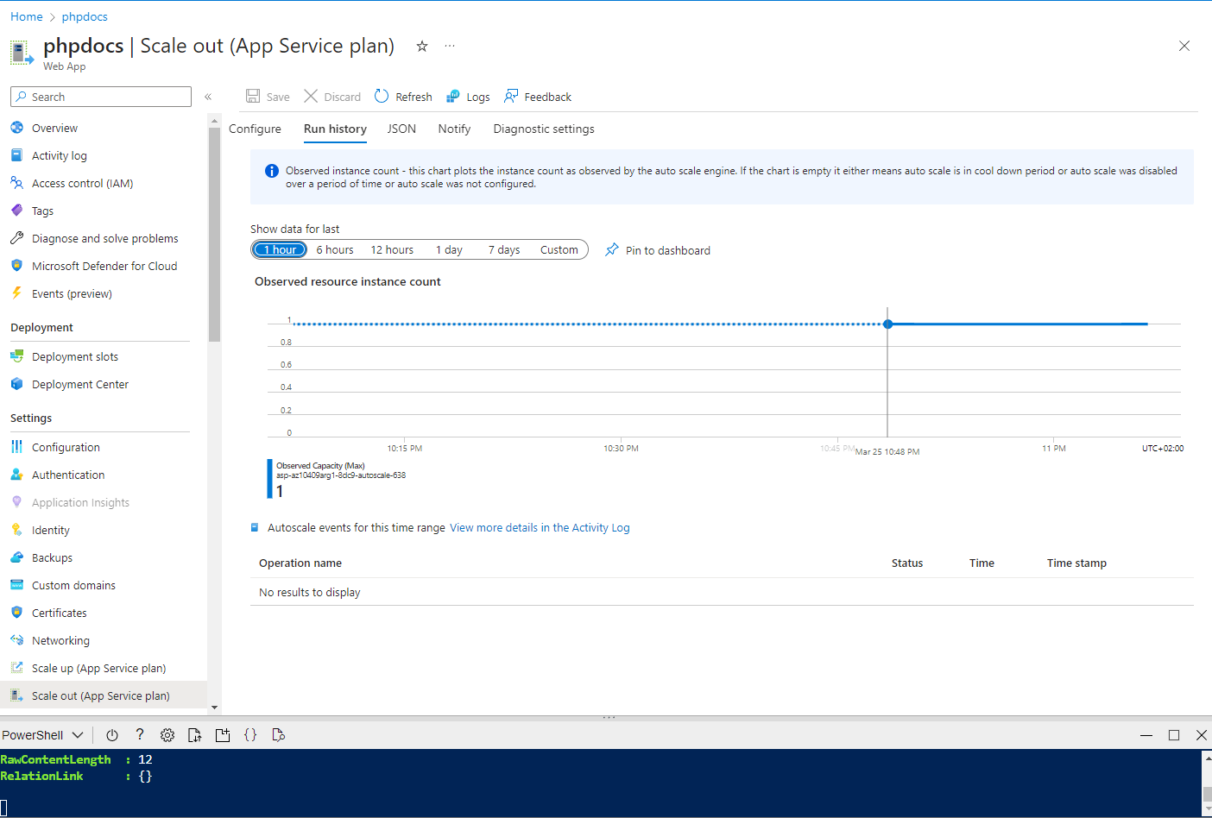

* + Monitoring, but after running for 15 minutes, the instances stayed 1.